4.0 Procedure

Part 1: Understanding Algorithms

1. 2. Consider the problem of finding the average of three numbers.
Write a step-by-step algorithm for solving the problem.

Example format:

Start
Input number1
Input number2
Input number3
Calculate average = (number1 + number2 + number3) / 3
Display the average
Stop

3. Discuss with your classmates how algorithms help programmers organise their thoughts before coding.

Algorithms help programmers organise their thoughts by breaking a problem into clear, logical steps before writing code. This makes it easier to understand what inputs, calculations, decisions, and outputs are needed. It can also help identify possible problems before stating the programming process.

Part 2: Writing Pseudocode

1. Convert the algorithm above into pseudocode.
Example:

BEGIN
PRINT "Average Calculator"
INPUT num1
INPUT num2
INPUT num3
SET total = num1 + num2 + num3
SET average = total / 3
PRINT average
END

2. Write pseudocode for the following problems:

a) Calculate the perimeter of a triangle.

BEGIN

INPUT side1
INPUT side2
INPUT side3

SET perimeter = side1 +side2 + side3

PRINT perimeter

END

b) Determine the greater of two numbers.

BEGIN

INPUT number1
INPUT number2

IF number1 > number 2 THEN
PRINT “Number 1 is greater than number 2”

ELSE IF number2 >number 1 THEN
PRINT “Number 2 is greater than number 1”

ELSE
PRINT “Both numbers are equal”

END

Part 3: Drawing Flowcharts

1. Draw a flowchart for the algorithm that calculates the average of three numbers.
Your flowchart should include the following symbols:

Symbol | Purpose
Oval | Start/End
Parallelogram | Input / Output
Rectangle | Process
Diamond | Decision

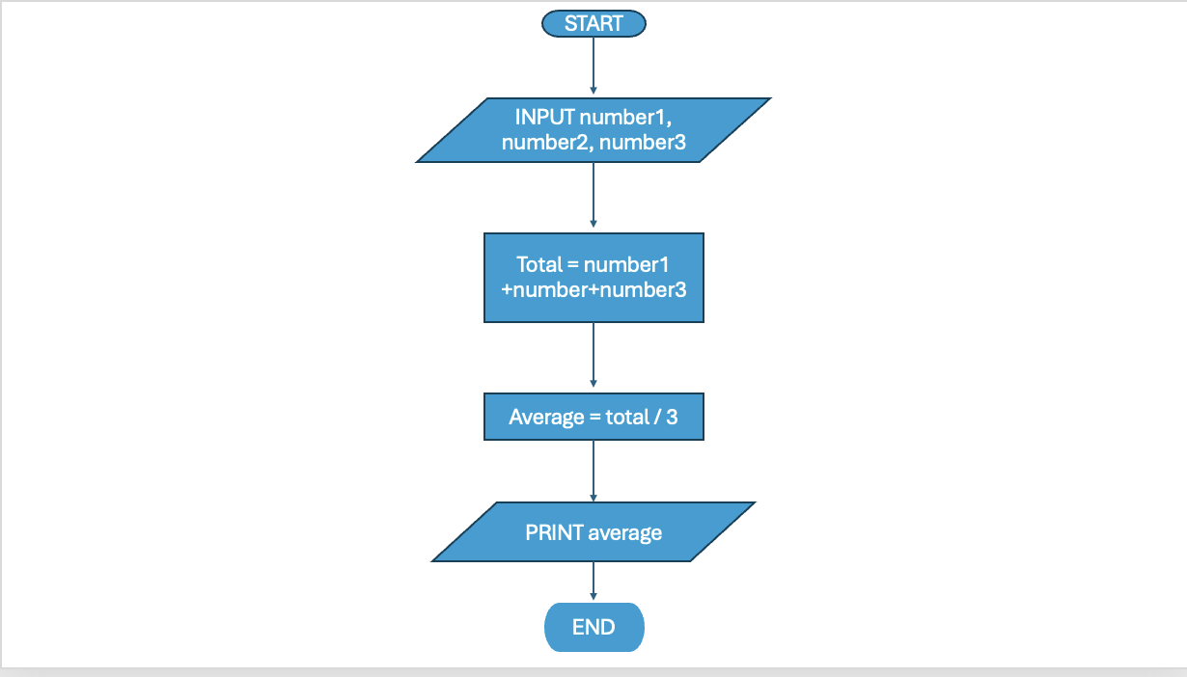

2. Draw a second flowchart for the following problem:
Problem:

Determine whether a number is even or odd.
Steps to consider:

• Input number
• Check if number % 2 == 0
• Display result
Students may draw flowcharts using:
• Microsoft Word
• PowerPoint
• draw.io
• paper and pen

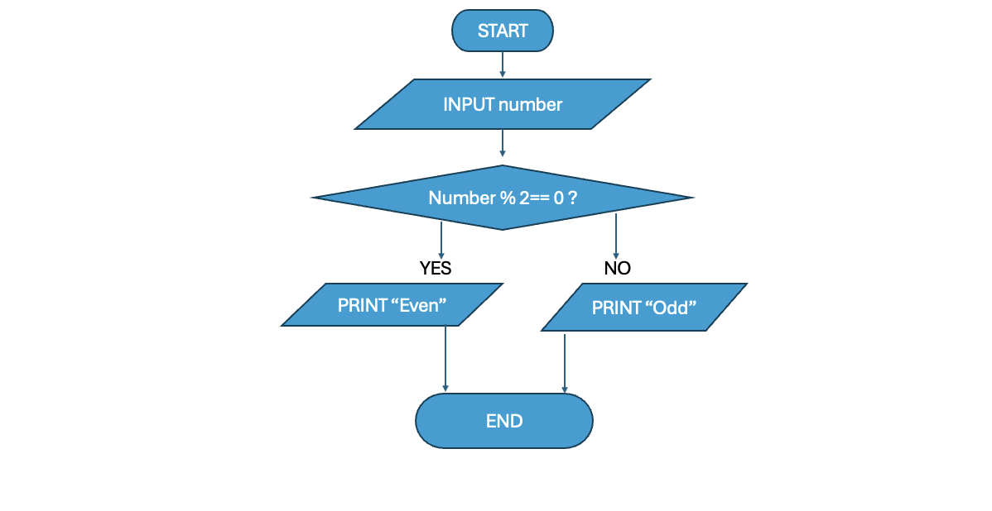

Part 4: Algorithm Design Practice

Design algorithms for the following problems:

Problem 1 – Largest of Three Numbers

Write an algorithm that determines the largest among three numbers.

- Input three numbers.
- Compare the first number with the second and third numbers.
- If the first number is greater than or equal to both, select the first number as the largest.
- Otherwise, compare the second number with the first and third numbers.
- If the second number is greater than or equal to both, select the second number as the largest.
- Otherwise, select the third number as the largest.
- Display the largest number.

Problem 2 – Simple Grading System

Write an algorithm that displays:

• “Pass” if score ≥ 50
• “Fail” if score < 50

- Input the score.
- Check if the score is greater than or equal to 50.
- If it is, display "Pass".
- Otherwise, display "Fail".

Part 5: From Algorithm to Python

Choose one of the problems above and convert the algorithm into a Python program.
Example problem ideas:

• Average calculator
• Even or odd checker
• Largest number finder

number1 = float(input("Enter the first number: "))
number2 = float(input("Enter the second number: "))
number3 = float(input("Enter the third number: "))

if number1 >= number2 and number1 >= number3:
print("The largest number is:", number1)

elif number2 >= number1 and number2 >= number3:
print("The largest number is:", number2)

else:
print("The largest number is:", number3)
Part 6: Challenge Task:

Design an algorithm and flowchart for a simple menu-driven calculator.
Your calculator should allow a user to:

1. Add numbers
2. Subtract numbers
3. Multiply numbers
4. Divide numbers

Think about:

• How the user chooses an option
• What happens after the operation
• How the program ends
You do not need to fully code this yet, but you should clearly design the logic.

1. Algorithm – Menu-Driven Calculator

- Start the calculator.
- Display the menu:
    - Add
    - Subtract
    - Multiply
    - Divide
    - Exit
- Ask the user to choose an option.
- If the user chooses 5, end the program.
- If the user chooses an option from 1 to 4, input two numbers.
- If the user chooses 1, add the two numbers.
- If the user chooses 2, subtract the second number from the first number.
- If the user chooses 3, multiply the two numbers.
- If the user chooses 4, check if the second number is zero.
- If the second number is zero, display "Cannot divide by zero". Otherwise, divide the first number by the second number.
- Display the result.
- Return to the menu so the user can choose another operation.
- If the user enters an invalid option, display "Invalid choice" and return to the menu.
- End when the user chooses 5. Exit.

2. Flowcharts
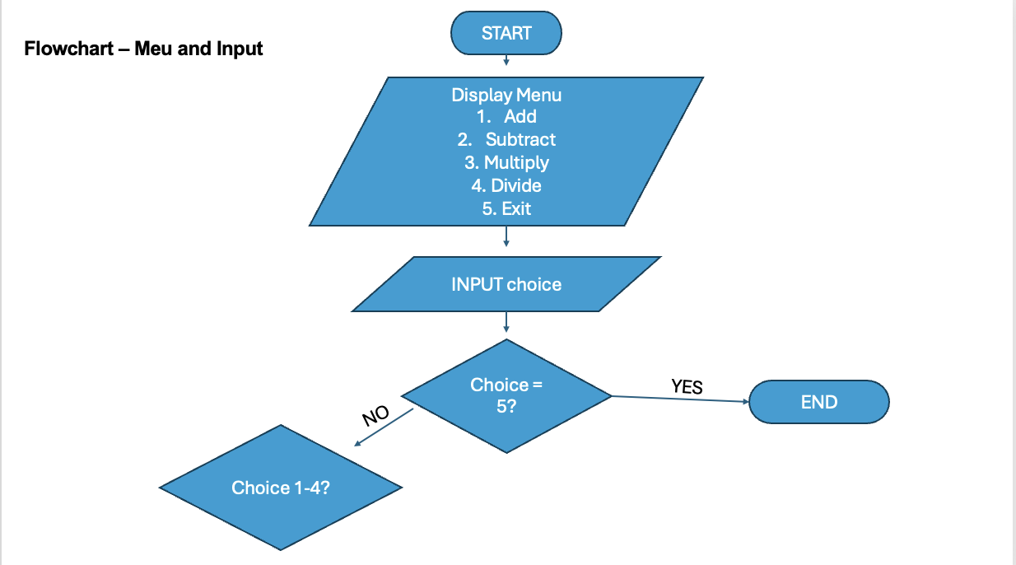

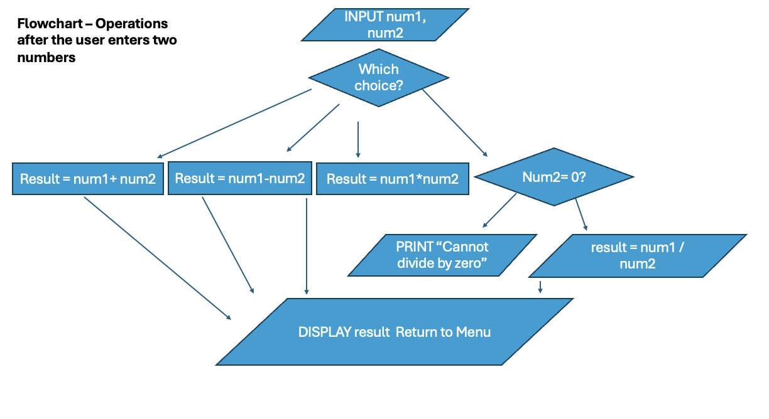

5.0: Student Reflection Questions

- Why is it useful to design algorithms before writing code?

Designing algorithms before writing code helps programmers organise their ideas and understand the steps needed to solve a problem. It can also help identify possible problems before starting to code.

- What is the difference between pseudocode and a flowchart?

Pseudocode represents the steps of an algorithm using structures text that is like programming code. A flowchart represents the same logic visually using shapes, symbols and arrows.

- Which representation (algorithm, pseudocode, or flowchart) helped you understand the problem best?

The flowchart helped me understand the problem best because I could visually see the sequence of steps and how decisions can change the direction of the program.

- What challenges did you face when translating an algorithm into a program?

One challenge was translating the logical steps of the algorithm into the correct Python syntax. I had to think about which programming structures to use, such as variables, if statements and loops, and make sure the indentation and syntax were correct.

